How to Purchase State Vehicles Using State Vehicle Contracts
- Select a vehicle from the FY 2018 state vehicle contract. To view options and more detailed information about the specs on a particular vehicle type, look at the Specifications and Pricing spreadsheet.

- Complete the a MV-6 (Agriculture departments: use this link instead).
Use the image and text below as a guide for filling out the MV-6.
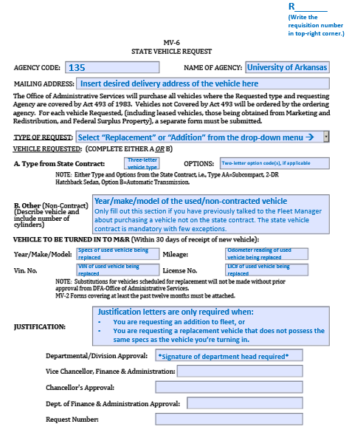
- Enter the requisition in BASIS/UPS using the regular RE type.
 | Less than 1 Ton | 1 Ton or greater
Vendor | Motor Vehicle Acquisition Revolving Fund  PO Box 2485  Little Rock, AR 72203) | Dealership  Dealership Address  See Item # column and Contractor column on page 4 or  Go to State Vehicle Contract Awards Summary for details to match the Item # from the Specifications and Pricing spreadsheet to the appropriate vendor and address.
Handling Codes | C, H | P
Hold For | Karen Walls | (Leave blank)
Description | Three-letter vehicle type/alpha code with description of the vehicle  E.g. ADA 4-dr Mid-Size Sedan: Ford Fusion

- The vehicle type should be line 1, and if you are adding any options, enter one line for each option starting with line 2.
- Delete any FREIGHT, TAX, or TOLERANCE. The requisition should be for the exact amount.
- Fleet vehicles must have a white exterior.
Example:

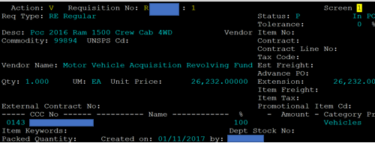

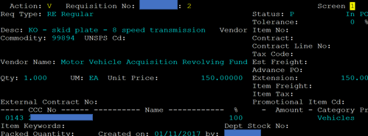

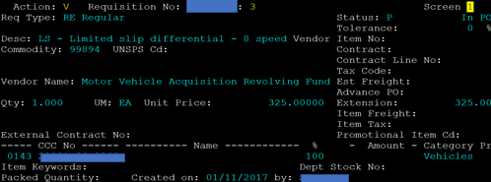

- When the requisition is approved through the target chain in your department in BASIS, write the requisition number in the upper right-hand corner of the MV-6 request form and then email it to me.

- I will enter the request into the DFA State Agency Vehicle Application (SAVA) system and send that to Little Rock for approval. Review by the DFA usually takes a week or so, unless there is pushback on the upgrade and a justification letter is needed.

For further assistance, contact:
Karen Walls, Fleet Manager
(479)575-6400
kwalls@uark.edu
2018 Contract At-A-Glance

