VENDORS WHO DO NOT WISH TO RESPOND TO A BID ARE NOT REQUIRED TO DO SO.
HOWEVER, VENDORS NOT RESPONDING AND/OR SUBMITTING A “NO BID” RESPONSE TO THREE CONSECUTIVE BID INVITATIONS FOR THE REQUESTED COMMODITY MAY BE REMOVED FROM THE UNIVERSITY’S BIDDERS LIST.
Please Print or Type
Company Name: |  |  | Phone:
Address:
 |  |  | Fax:
City: |  |  | EMail:
State: |  |  | Web Site:
Zip Code: |  |  | Tax ID or SSN:

THIS OFFICIAL BID SHEET MUST BE SIGNED AND RECEIVED IN A SEALED ENVELOPE WITH VENDOR NAME, BID NUMBER, AND BID OPENING DATE CLEARLY NOTED ON OUTSIDE OF ENVELOPE.

BIDS MAY NOT BE FAXED DIRECTLY TO UNIVERSITY IN RESPONSE TO THIS INVITATION FOR BID.

Please Note: The above listed date and time is the LATEST the bid will be accepted. ANY bids received after that time will NOT be considered.

BID WILL BE ACCEPTED EITHER SIGNED IN INK OR WITH ELECTRONIC OR FACSIMILE SIGNATURE.
PLEASE ENCLOSE ONE EXTRA COPY OF SIGNED BID.

Name (Type or Print): ________________________________ Title: _______________________________

Signature: ________________________________ Date:_______________________________

STANDARD TERMS AND CONDITIONS

1. | PREPARATION OF BIDS
 | 1.1 | Failure to examine any drawings, specifications, and instructions will be at bidder’s risk.
 | 1.2 | All prices and notations must be printed in ink or typewritten. No erasures permitted. Errors may be crossed out and corrections printed in ink or typewritten adjacent, and must be initialed in ink by person signing bid.
 | 1.3 | Brand Name References: Unless specified “No Substitute” any catalog brand name or manufacturer’s reference used in the bid invitation is descriptive only, not restrictive, and used to indicate the type and quality desired. If bidding on other than referenced specifications, the bid must show the manufacturer, brand or trade name, and other descriptions, and should include the manufacturer’s illustrations and complete descriptions of the product offered. The University reserves the right to determine whether a substitute offered is equivalent to and meets the standards of the item specified, and the University may require the bidder to supply additional descriptive material, samples, or demonstrators. The bidder guarantees that the product offered will meet or exceed the referenced product and/or specifications identified in this bid invitation. If the bidder takes no exception to the specifications, bidder will be required to furnish the product exactly as specified in the invitation.
 | 1.4 | Samples: Samples or demonstrators, when requested, must be furnished free of expense to the University. Samples not destroyed during reasonable examination will become property of the University unless bidder states otherwise. All demonstrators will be returned after reasonable examination. Each sample should be marked with the bidder’s name and address, bid number and item number.
 | 1.5 | Time of Performance: The number of calendar days in which delivery will be made after receipt of order shall be stated in the bid.
2. | SUBMISSION OF BIDS
 | 2.1 | Bids, modifications or corrections thereof received after the closing time specified will not be considered.
3. | ACCEPTANCE OF BIDS
 | 3.1 | The University reserves the right to accept or reject all or any part of a bid or any and all bids, to waive any informality, and to award the bid to best serve the interest of the University.
 | 3.2 | If a bidder fails to state the time within which a bid must be accepted, it is understood and agreed that the University shall have 60 days to accept.
4. | ERROR IN BID
 | 4.1 | In case of error in the extension of prices in the bid, the unit price will govern. No bid shall be altered or amended after the specified time for opening bids.
5. | AWARD
 | 5.1 | Contracts and purchases will be made or entered into with the lowest responsible bidder meeting specifications or on the basis of best value.
 | 5.2 | When more than one item is specified in the Invitation, the University reserves the right to determine the low bidder either on the basis of the individual items or on the basis of all items included in its Invitation for Bids, or as expressly stated in the Invitation for Bid.
 | 5.3  5.4 | A written purchase order or contract award mailed, or otherwise furnished, to the successful bidder within the time of acceptance specified in the Invitation for Bid results in a binding contract without further action by either party. The contract shall not be assignable by the vendor in whole or part without the written consent of the University.  Vendors awarded contracts for commodities and/or services are encouraged to participate in our University Shopping Mall. This online catalog database is operated by a third party provider and will allow all University departments to place orders to multiple vendors online. A monthly maintenance fee, to be negotiated between each vendor and the shopping mall data base provider, is required.
6. | DELIVERY
 | 6.1 | The Invitation for Bid will show the number of days to place a commodity in the University designated location under normal conditions. If the bidder cannot meet the stated delivery, alternate delivery schedules may become a factor in award. The University has the right to extend delivery if reasons appear valid.
 | 6.2 | Delivery shall be made during University work hours only, 8:00 a.m. to 4:30 p.m.., unless prior approval for other shipment has been obtained.
 | 6.3 | Packing memoranda shall be enclosed with each shipment.
7. | ACCEPTANCE AND REJECTION
 | 7.1 | Final inspection and acceptance or rejection may be made at delivery destination, but all materials and workmanship shall be subject to inspection and test at all times and places, and when practicable. During manufacture, the right is reserved to reject articles which contain defective material and workmanship. Rejected material shall be removed by and at the expense of the contractor promptly after notification of rejection. Final inspection and acceptance or rejection of the materials or supplies shall be made as promptly as practicable, but failure to inspect and accept or reject materials or supplies shall not impose liability on the University thereof for such materials or supplies as are not in accordance with the specification. In the event necessity requires the use of materials or supplies not conforming to the specification, payment may be made with a proper reduction in price.
8. | TAXES AND TRADE DISCOUNTS
 | 8.1 | Do not include state or local sales taxes in bid price.
 | 8.2 | Trade discounts should be deducted from the unit price and net price should be shown in the bid.
9. | DEFAULT
 | 9.1 | Back orders, default in promised delivery, or failure to meet specifications authorize the University to cancel this contract to the defaulting contractor. The contractor must give written notice to the University of the reason and the expected delivery date.
 | 9.2 | Consistent failure to meet delivery without a valid reason may cause removal from the bidders list or suspension of eligibility for award.
10. | WAIVER
 | 10.1 | The University reserves the right to waive any General Condition, Special Condition, or minor specification deviation when considered to be in the best interest of the University, so long as such waiver is not given so as to deliberately favor any single vendor and would have the same effect on all vendors.
11. | CANCELLATION
 | 11.1 | Any contract or item award may be canceled for cause by either party by giving 30 days written notice of intent to cancel. Cause for the University to cancel shall include, but is not limited to, cost exceeding current market prices for comparable purchases; request for increase in prices during the period of the contract; or failure to perform to contract conditions. The contractor will be required to honor all purchase orders that were prepared and dated prior to the date of expiration or cancellation if received by the contractor within period of 30 days following the date of expiration or cancellation. Cancellation by the University does not relieve the Contractor of any liability arising out of a default or nonperformance. If a contract is canceled due to a request for increase in prices or failure to perform, that vendor shall be removed from the Qualified Bidders List for a period of 24 months. Cause for the vendor to cancel shall include, but is not limited to the item(s) being discontinued and unavailable from the manufacturer.
12. | ADDENDA
 | 12.1 | Addenda modifying plans and/or specifications may be issued if time permits. No addendum will be issued within a period of three(3) working days prior to the time and date set for the bid opening. Should it become necessary to issue an addendum within the three-day period prior to the bid opening, the bid date will be reset giving bidders ample time to answer the addendum.
 | 12.2 | Only written addenda is part of the bid packet and should be considered.
13. | ALTERNATE BIDS
 | 13.1 | Unless specifically requested alternate bids will not be considered. An alternate is considered to be a bid that does not comply with the minimum provisions of the specifications.
14. | BID OPENINGS
 | 14.1 | Bid opening will be conducted open to the public. However, they will serve only to open, read and tabulate the bid price on each bid. No discussion will be entered into with any vendor as to the quality or provisions of the specifications and no award will be made either stated or implied at the bid opening.
15. | DEBRIS REMOVAL
 | 15.1 | All debris must be removed from the University after installation of said equipment.

ALL BIDS SUBMITTED SHALL BE IN COMPLIANCE WITH THE GENERAL CONDITIONS SET FORTH HEREIN. THE BID PROCEDURES FOLLOWED BY THIS OFFICE WILL BE IN ACCORDANCE WITH THESE CONDITIONS. THEREFORE, ALL VENDORS ARE URGED TO READ AND UNDERSTAND THESE CONDITIONS PRIOR TO SUBMITTING A BID.

Please send 1 signed copy 1 extra copy of your response to this bid. The extra copy is needed for bid evaluation purposes. Please do not send bid responses to different bids in the same envelopes. Thank You!

Item | Description | Qty |  | Unit Price |  | Total Price

1. LiDAR Elevation Data per the attached 1ea $________ $_________
specifications:

NOTE: If any portion of a vendor's contract terms and conditions are in conflict with those in this Invitation for Bid or with the laws of the State of Arkansas, State of Arkansas laws shall govern. Failure to conform to these standards may result in rejection of bid.

NOTE: If offering equal, full description and complete specifications must accompany bid at the time of bid opening. Failure to do so may result in disqualification of bid.

NOTE: Bids must be submitted on this official bid form to be considered.

FOB: University of Arkansas
Center for Advanced Spatical Tehnologie
JBHT Room 304
Fayetteville, AR 72701

Delivery___________ days after receipt of order.

If further information is needed please contact: Jackson Cothren at 479-575-7919 or jcothre@uark.edu.

General Campus Background for University of Arkansas

Established in 1871 as a land grant institution, the University of Arkansas is the only comprehensive doctoral degree granting institution in Arkansas. It is classified as a Carnegie Foundation Doctoral/Research University. The University campus includes 360 buildings on 357 acres. The University offers more than 230 undergraduate and graduate degrees in more than 150 fields of study in agricultural, food and life sciences, arts and sciences, business, education, engineering, architecture and law. As of Fall 2011, student enrollment was 23,199 (undergraduate 17,327, professional 399, graduate 3616, and non-degree 410; full-time 16,617 and part-time 2,410). The faculty count was 989, and staff count was 2863. The University is the flagship campus for the University of Arkansas System.

Ethical Standards

“It shall be a breach of ethical standards for a person to be retained, or to retain a person, to solicit or secure a state contract upon an agreement or understanding for a commission, percentage, brokerage, or contingent fee, except for retention of bona fide employees or bona fide established commercial selling agencies maintained by the contractor for the purpose of securing business”

Technology Access

The Vendor expressly acknowledges that state funds may not be expended in connection with the purchase of information technology unless that system meets certain statutory requirements, in accordance with State of Arkansas technology policy standards relating to accessibility by persons with visual impairments.

Accordingly, the Vendor represents and warrants to University of Arkansas, Fayetteville that the technology provided to University of Arkansas for purchase is capable, either by virtue of features included within the technology or because it is readily adaptable by use with other technology, of: (1) providing equivalent access for effective use by both visual and nonvisual means; (2) presenting information, including prompts used for interactive communications, in formats intended for nonvisual use; and (3) being integrated into networks for obtaining, retrieving, and disseminating information used by individuals who are not blind or visually impaired.

For purpose of this paragraph, the phrase “equivalent access” means a substantially similar ability to communicate with or make use of the technology, either directly by features incorporated within the technology or by other reasonable means such as assisting devices or services which would constitute reasonable accommodations under the American with Disabilities Act or similar state or federal laws. Examples of methods by which equivalent access may be provided include, but are not limited to, keyboard alternatives to mouse commands and other means of navigating graphical displays, and customizable display appearance.

If requested, the Vendor must provide a detailed plan for making this purchase accessible and/or a validation of concept demonstration.

Dun and Bradstreet DUNS Number
We highly encourage all University of Arkansas contract vendors to use a Dun and Bradstreet number (DUNS Number). The D & B DUNS Number is a unique nine digit identification sequence, which provides unique identifiers of single business entities, while linking corporate family structures together. If your business has not registered, you may do so at:
http://www.dnb.com/
If available, please provide your Dun and Bradstreet DUNS Number below:
_______________________________________

University of Arkansas Logo / Trademark Licensing:

Merchandise that carries a University logo or trademark must be purchased from vendors that are licensed through the Collegiate Licensing Corporation. Therefore, bidders are required to be currently licensed to carry the University of Arkansas logo in order to be eligible to submit bids for those requests that involve the University of Arkansas logo or trademark. Only those offers submitted by currently licensed bidders will be considered for award.

Request for Bids
LiDAR and Derivative Products for a portion of the Little Red River Irrigation Project Area
University of Arkansas, Fayetteville

I. PROGRAM SCOPE AND DESCRIPTION

Light Detection and Ranging (LiDAR) elevation data is to be collected for an area generally encompassing the Little Red River Irrigation Project Area in the northeast and north central areas of Arkansas (total of 205 sq. mi.), as shown on Attachment A. The actual project area of interest (AOI) will be provided as an ArcGIS shapefile. Derivative products will be processed from the LiDAR elevation data. The LiDAR and derivative product requirements, standards and specifications are provided in Section III (below).

II. PERIOD OF PERFORMANCE

The LiDAR must be collected during leaf-off, snow-free conditions in late fall 2012 or early winter 2013, and delivered by March 30, 2013.

III. DELIVERABLES, DATA ACCESS and DELIVERY

Deliverables include:

- Full point cloud data at:
  - 0.5 m Nominal Pulse Spacing (NPS) and 9.25 cm Vertical RMSE accuracy

The minimum standards that will be used are the USGS NGP Base Lidar Specification v13. Deliverable specifications are as follows:

Requirement | Specifications
Nominal Pulse Spacing (NPS) | Shall be no greater than 0.5 NPS
Collection Conditions | Leaf off, snow-free, less than 0.25 inches of precipitation in previous 3 days
Vertical Accuracy (in open terrain) | 9.25 cm Vertical RMSE accuracy
Datum | Vertical: NAVD 88  Horizontal: NAD 83
Coordinate System | UTM Zone15N
Units | Vertical: Feet  Horizontal: Meters to two decimal places
Metadata | Project level metadata, including data accuracy and collection specifications, will accompany each product delivered. In the metadata documentation, specific reference will be made to funding sources.
Tile Size | Mass Points: 1500m x 1500m filled to project shapefile; using USGS base lidar spec v13 for overlap on incomplete tiles.  Tiled deliverables shall conform to the tiling scheme, without added overlap.  Tiling scheme will be used for all tiled deliverables.  Tiled deliverables shall edge-match seamlessly in both the horizontal and vertical.  NOTE: Tile Coverage: tiles that lie completely within the project area shall be complete to the tile edges. Tiles that lie partially outside the project boundary shall be complete to the project boundary with enough overlap beyond the project boundary to ensure that no parts of the project are omitted.
Data Delivery Method | On portable hard drive

Notification of Data Collection

The contractor shall notify the University of Arkansas (UA) project coordinator of the scheduled LiDAR collection date at least one (1) week prior to, and again one (1) day prior to the scheduled collection. The contractor shall provide the UA project coordinator confirmation of the commencement of the LiDAR collection on the day the collection commences. The purpose of the notifications is to provide UA the opportunity to collect ground-based data concomitant with LiDAR data collection.

IV. QUALITY ASSURANCE REVIEWS AND ACCEPTANCE OF DATA

All QA/QC reviews of the data will be evaluated on the National Standard of 95% of the points meeting the standard over the entire dataset. If the inspection reveals deficiencies or defects, the data or issues will be required to be resolved at no additional cost to UA. Initial acceptance of the deliverables by UA does not relieve the LiDAR provider from the responsibility to correct defective work with no further cost to UA for a period of one year following initial acceptance.

Preliminary Review of Data

Within 7 days of the LiDAR data collection, the contractor shall deliver a partial data set to the UA (who must deliver data preview to USDA-NRCS National Geospatial Management Center (NGMC) within 14 days of collection) for a preliminary review of the data. The partial data set shall include data for both cropland and forest cover types.

Cursory Review of Completed Deliverables

Upon completion of the deliverables identified in Section III of this document, the contractor shall deliver a copy of the deliverables to the UA for review. UA shall have 90 days to inspect the data for quality and completeness, and return the data to the contractor. Should deficiencies in the data be discovered, the UA POC will provide documentation of deficient data to the Contractor. The Contractor will evaluate what action to take to correct the data, or provide technical support in order for users to correct the data. Resolution of data deficiencies will be based on the mutual consent of UA and the contractor.

Independent QA/QC Review

UA, at its option, may elect to contract the services of an independent contractor for QA/QC review of all deliverables to ensure conformance to the specifications identified in Section III of this document. If the independent QA/QC review reveals any defect or deviation in the manufacture of the items that would make them unfit for the purpose intended, the Contractor will be required to satisfactorily remedy such conditions at no additional cost to UA. The independent QA/QC review will be completed within one year of the initial acceptance of the deliverables by UA.

V. USE AND DISTRIBUTION RIGHTS: All deliverable data and documentation shall be free from restrictions regarding use and distribution. Data and documentation provided under this Task Order shall be freely distributable by government agencies.

VI. UA POINTS OF CONTACT

Project Coordinator: Jackson Cothren
JBHT 304
University of Arkansas
Fayetteville, AR, 72701
Phone: (479) 575-5421
Fax: (479) 575-2816
jcothren@cast.uark.edu

Contracting Officer: Ellen Ferguson
Business Services
321 Administration Building
Campus Mail Stop: ADMN 321
Phone: (479) 575-2551
Fax: (479) 575-4158
ellenf@uark.edu
APPENDIX A: AREA OF INTEREST
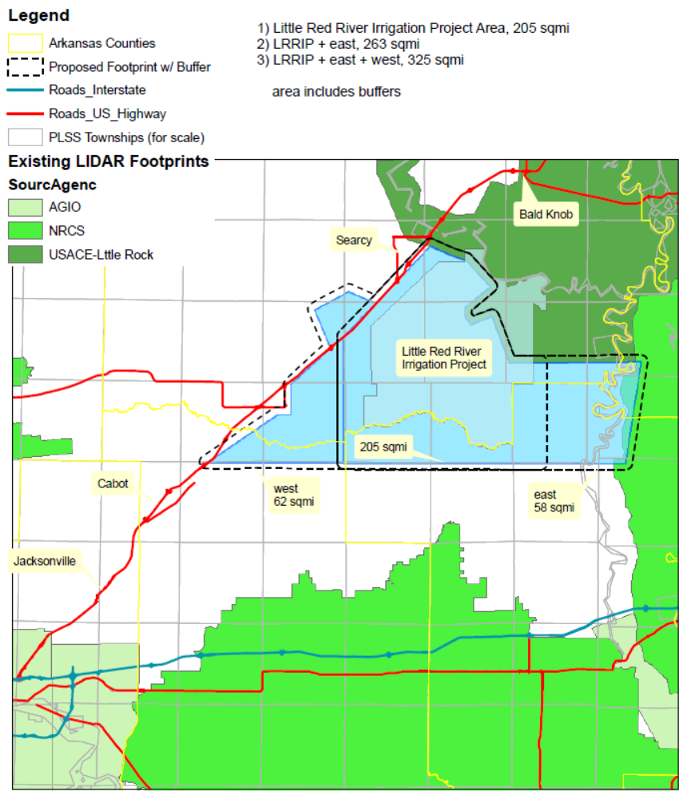

Equal Opportunity Policy Disclaimer

ATTENTION BIDDERS

Act 2157 of 2005 of the Arkansas Regular Legislative Session requires that any business or person bidding, who is responding to a formal bid request, Request for Proposal or Qualification, or negotiating a contract with the state for professional or consultant services, submit their most current equal opportunity policy (EO Policy).

Although bidders are encouraged to have a viable equal opportunity policy, a written response stating the bidder does not have such an EO Policy will be considered that bidder’s response and will be acceptable in complying with the requirement of Act 2157.

Submitting the EO Policy is a one-time requirement. The University of Arkansas, Fayetteville Procurement Department, will maintain a database of policies or written responses received from all bidders.

Note: This is a mandatory requirement when submitting an offer as described above.

Please complete and return this form with your bid response.

Should you have any questions regarding this requirement, please contact this office by calling (479) 575-2551.

Sincerely,

Linda Fast

Linda Fast, CPPO, CPPB, APO
Manager of Procurement Services
University of Arkansas
Fayetteville, AR

To be completed by business or person submitting response: (check appropriate box)

____ EO Policy Attached

____ EO Policy previously submitted to UA Purchasing Department

____ EO Policy is not available from business or person

Company Name
Or Individual: __________________________________________________________

Title: _____________________________________Date: ______________________

Signature: ____________________________________________________________
UNIVERSITY OF ARKANSAS
PROCUREMENT DEPARTMENT
1125 W. Maple ADMIN 321
Fayetteville, AR 72701
Tel: 479-575-2551
Fax: 479-575-4158

Act 157 of 2007 of the Arkansas Regular Legislative Session requires that any contractor, business or individual, having a public contract with a state agency for professional services, technical and general services, or any category of construction, in which the total dollar value of the contract is $25,000 or greater must certify, prior to the award of the contract, that they do not employ or contract with any illegal immigrants.

For purposes of this requirement, “Illegal immigrants” means any person not a citizen of the United States who has:

- Entered the United States in violation of the Federal Immigration and Naturalization Act or regulations issued the act;
- Legally entered but without the right to be employed in the United States; or
- Legally entered subject to a time limit but has remained illegally after expiration of the time limit.

This is a mandatory requirement. Failure to certify will result in our inability to issue a Purchase Order or Contract to you or your company.

Bidders shall certify online at http://www.arkansas.gov/dfa/procurement/pro_immigrant.html
Click on: “Procurement” on left-side information bar
Click on: Illegal Immigrant Reporting
Click on: “Vendor” Illegal Immigrant Contracting Disclosure Reporting Screen
Click on: “Vendor Submit Disclosure Form” to complete all fields required for the certification – then indicate below and sign this form to submit with your bid. ***NOTE*** Bid Number field is applicable if known.
REQUIRED: Print Screenshot and include with your proposal and/or contract.

If you have any questions, please call the UA Procurement Department at 479-575-2551.

Thank you.
Linda K. Fast
Linda K. Fast, CPPO, CPPB, APO
Manager of Procurement Services
University of Arkansas

**********************************************************************************************
TO BE COMPLETED BY BUSINESS OR PERSON SUBMITTING BID RESPONSE OR CONTRACT:

Please check the appropriate statement below:

_______ We certified that we are not an illegal immigrant
or do not employ or contract with any illegal immigrants.

Date of certification: ________________________

_______ We cannot so certify at this time, and we understand that
a contract cannot be awarded until we have done so.

Reason for non-certification: ______________________________

Name of Company: ___________________________________________

Signature: ___________________________________________

Name & Title: ___________________________________________
(Printed or typed)
Date: ___________________________________________



